***Exercise Lab 5***

***Sec : D***

**Question # 01:** Write a program which takes 8 numbers as input in variables a-h, then computes the following formula and displays the output to screen.



**Question # 02:** Write a C program which takes marks of subjects Physics, Chemistry, Biology, Mathematics and Computer as input from the student then Calculates his percentage and display the result card on the output screen.

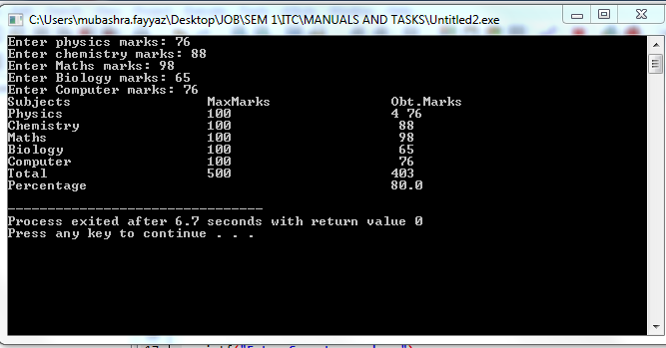

**Question # 03:**

1. Write a program that asks user for temperature in Celsius and convert it into Fahrenheit.
2. Write a program that asks user for temperature in Fahrenheit and convert it into Celsius.

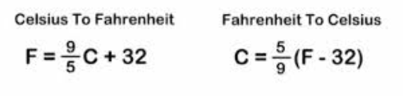

(Note: There should be only 3 digits after the decimal point if output contains a fractional value)

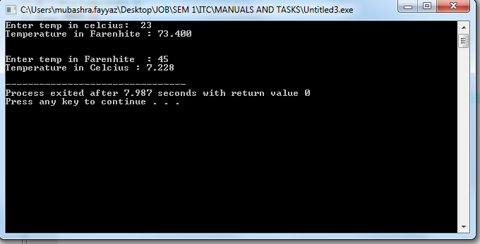

**Question # 04:** Raza was not feeling well; he went to the doctor. Doctor check Raza and prescribe him 3 tablets in the morning, 5 tablets in the afternoon and 3 tablets at night. Based on the input find out the total number of tablets Raza takes in a day.

**Question # 05:** Generate the following output. (hint: ASCII value of ☺ is 1)

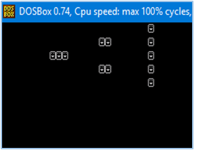

**Question # 06:** Write a program to display the size of different data types on different lines. (Hint: Use sizeof() Function)

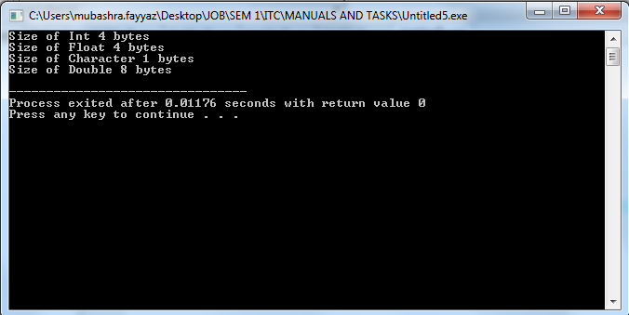

**Question # 07:** Write a program that asks user to give number of days as input and returns the number of years, weeks, and days. Assume every year has 365 days and every month is of 30 days.

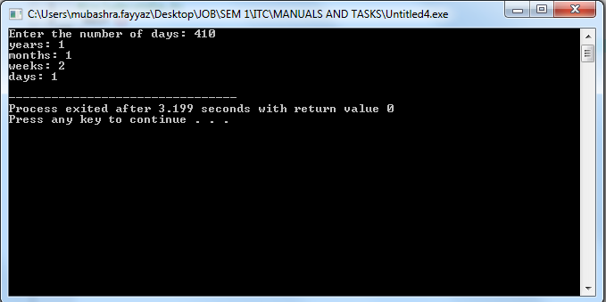

**Question # 08:** Write down the following programs, display the output, if there is an error in program then correct it.

* 1. Void main ( )

{ Int I ; I=0x10+ 010+10; Printf (“\nx=%x”, i); }

* 1. Void main ( )

{ Printf (“\n ABC\b\b\bInfo World”); }

* 1. void main ( )

{ printf(“%d”,’B’ < ‘A’ ); }

* 1. main()

{ int x , y ; x = 753; y = 722; printf(“ x & y is %@” , x & y ); }

* 1. main()

{ int x , y; x = 2003; x++; y = x++; y = x; y++; x—; x— printf (“%d%d”,x,y);